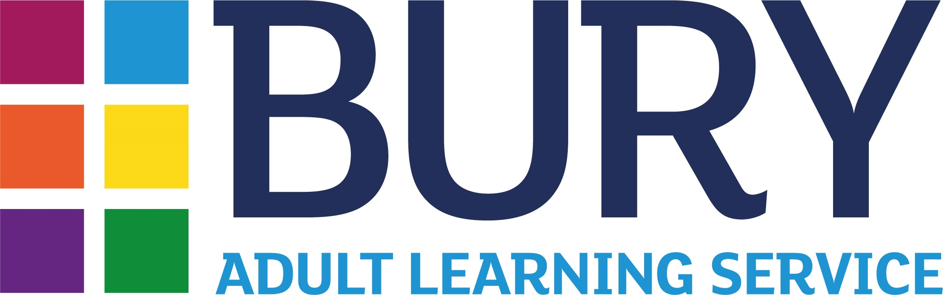
Course Information Sheet 2024/25
Work & Wellbeing Qualification Course

Course title: | Level 2 Award for Young Health Champions |  |  |  |  |  |  | Code:  WWHI400
Tutor: | Liz Jones
Day & Time: | Thursday & Friday 9.30am-3.00pm
Start & End Dates: | Term 1 |  | Term 2  6th & 7th February  13th & 14th February |  |  | Term 3
Number of sessions: |  |  | 4 |  |  | 4
Venue: | BALC |  |  |  |  | Room No:19
Learner numbers: | Minimum 6 |  |  |  | Maximum 12
Costs: | Full Fee |  |  |  | Discounted Fee
Costs: | Term 1 | Term 2 |  | Term 3 | Term 1 |  | Term 2 |  | Term 3
Costs: |  | £119.00 |  |  |  |  | Free

What will I learn on this course?
If you are interested in enrolling on this course, please ring us on 0161 253 5772.

This course will provide you with an understanding of the principles of promoting health and wellbeing and enable you to direct your peers towards further practical support in their efforts to attain a healthier lifestyle.

This qualification covers examples of inequalities in health within the UK, their possible causes and current approaches to tackling these inequalities. You will learn how effective communication can support health messages, how to promote improvements in the health and wellbeing of others and to understand the impact of behaviour change on improving an individual’s health and wellbeing.

This qualification is for young people who want a stake in society. They will grow in confidence as they learn how they can become a young leader that tackles inequality and inspires their peers. It is for existing or aspiring health champions and volunteers, aged between 19-29 years old who wish to improve the health and wellbeing of people in their local community by motivating and encouraging them to make positive lifestyle choices.

By the end of the course, I will be able to:
- Understand the Principles of Health Improvement
- Research local Health Improvement Services
- Deliver a Health Improvement Message
- Understanding Alcohol Misuse

Learning Aim and Level

Royal Society for Public Health Level 2 Award for Young Health Champions (603/2751/0)

Additional information
This qualification is for individuals with an interest in health and wellbeing who want to help their peers develop a healthier lifestyle. The objective of the qualification is to develop the competencies required of a young health champion. It will enable learners to provide peer support through an understanding of the individual and social drivers of healthy and unhealthy behaviours, as well as signposting to local health services. It will also provide knowledge of a health and wellbeing issue relevant to the learner and develop skills to deliver positive health messages.

Before you enrol on a course, advice and information is available to help you decide on the right course for you. Contact Learner Services on 0161 253 7501 or
e-mail at learner.services@bury.gov.uk.

A pre-course interview is required for this course, please contact 0161 253 5772 to arrange.

Attendance at all sessions is essential. If you miss a session without letting us know you may be asked to leave the course.

Please bring proof of identity to your first session – see page 3 for details.

Joining requirements
You will need to have a good understanding of the English language and if you are an ESOL learner you must have at least a Level 1 qualification.

No prior experience required.

What could I do next?
We have courses in Health and Social Care which could lead you into Bury College as you build up your confidence. From this course you could enrol onto another course within our Course Guide or progress to college. You could consider beginning a career as a Health Trainer or other health champion role within your community.

Your tutor will be able to advise on the options available to you in their subject. If you would like to speak to someone about moving on, please ask your tutor to refer you to Learner Services or contact them directly on 0161 253 7501 or email learner.services@bury.gov.uk .

Can I get extra help?
Support with English and Maths is available through our Skills for Life section. For more information, please contact Learner Services on 0161 253 7501.

Extra support is available for those learners who have sensory, physical or cognitive impairments, neuro-divergent or with mental health conditions.

Help with paying for your course
This course may be free if you are unemployed and claim benefits and want to be employed or progress into more sustainable employment. You may also qualify for a free course if you are on a low wage. Please enquire at the time of enrolment.

Please see the course guide for more information or ask at the time of enrolment. You will be asked to produce evidence to qualify for free provision or sign to say what benefits you are claiming and that you are seeking work.
If you are enrolling on a course which leads to a qualification and are finding it difficult to pay your exam fees or need financial help with childcare, small items of equipment or some travel cost, you may qualify for help from the Learner Support Fund. Ask at the Bury Adult Learning Centre office for a form or ring Learner Services on 0161 253 7501. If you have been mandated on to a course by Job Centre Plus you may not be able to get help from this fund.

How to enrol
Phone: 0161 253 5772
Call into: Bury Adult Learning Centre, 18 Haymarket Street, Bury, BL9 0AQ

Please keep your copy of this information sheet. It will be useful throughout your course.

Proof of Learner Identity

All certificated courses require you to show proof of your personal identity.
Please bring the relevant IDs on the first day of the course. Refer to the list below.

List of documents to show proof of learner identity

To comply with the new exam board regulation, you will be required to show proof of your identity before you could sit for a formal assessment. All Learners must bring proof of identity to the first session.

You are required to provide either:
- One item from the first list; or
- Two items from the second.

List 1: One item required
- Passport.
- EC identity card.
- Full driver’s licence (with photo).

List 2: Two of the following which are currently in use, are required
- Standard acknowledgement letter (held by people seeking asylum).
- Rent book/tenancy agreement.
- Current credit card or charge card.
- Bank or Building Society book.
- Letter showing home address.
- Full driver’s licence (non-photo).
- ES40 and JSA agreement.
- Medical card.
- Services identity card.
- Household Utility bills.
- Bail sheets.
- Original birth certificate.
- Marriage certificate.
- Senior Citizen travel-pass with photograph.
- Any other form of ID.

If you have any questions, please discuss them with your tutor on the first session of the course.

