Poster TRANSFORM STUDY http://www.tinyurl.com/r98x6asa
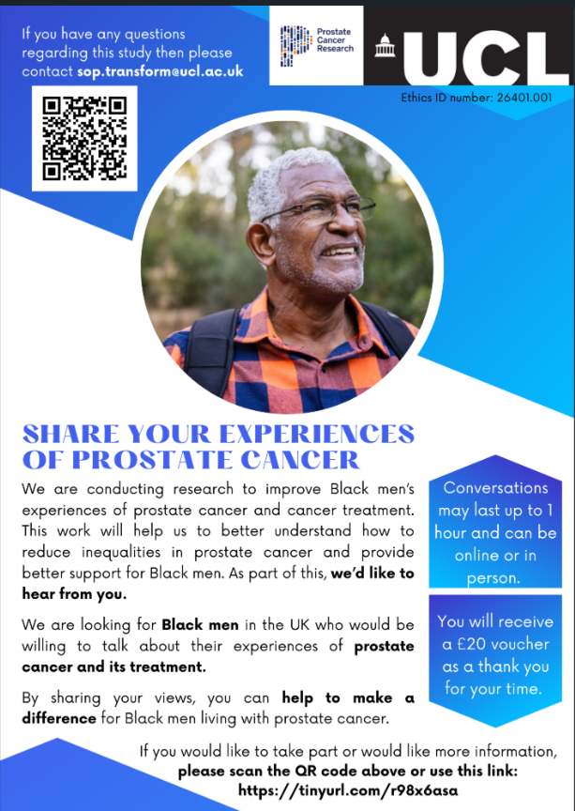
www.Tinyurl.com/r98x6asa
Information sheet Transform

Participant Information Sheet For Black Men with Prostate Cancer
UCL Research Ethics Committee Approval ID Number: 26401.001
YOU WILL BE GIVEN A COPY OF THIS INFORMATION SHEET
Title of Study: Exploring the Treatment Experiences of Black Men Living with Prostate Cancer: A Qualitative Study

We would like to invite you to take part in a research study conducted by University College London and Prostate Cancer Research.
You will have the opportunity to read this information and ask any questions. You will then be able to decide if you are interested in taking part in the study. If you would like more time to think about it, you can contact the researcher at a later date.
What is this research about?
In the UK, Black men are twice as likely to be diagnosed with prostate cancer in their lifetimes than white men; they are also more likely to die of the disease. The study aims to understand what it is like for Black men to take treatment for Prostate Cancer. This is part of a larger project which aims to explore ways to improve treatment options and care for people with Prostate Cancer, particularly for Black, Black African and Black Caribbean men. The larger study will also identify whether certain treatments for Prostate Cancer are more effective for men of different ethnicities.
In these interviews, we would like to find out how you feel about your prostate cancer and its treatment. This information will be used to develop ways to better support Black men in the future.
The experiences of Black men are not always heard, so we are particularly interested in hearing your voice. Your unique experiences can provide invaluable insights, which can help shape future efforts working towards better care and support for Black men with prostate cancer. It is hoped this will contribute towards reducing inequalities and disparities in the future.
1. Why have I been asked to take part?
We have asked you to participate in the study because we are interested in hearing from Black men aged 18 years or older taking treatment for Prostate Cancer.
2. Do I have to take part?
It is up to you if you would like to take part in the study; participation is entirely voluntary. If you are interested in taking part, we will ask you to sign a consent form. You are free to change your mind and withdraw your data from the study up to one week after the interview, without giving a reason. This will not affect your standard of care. If you do decide to withdraw your data from the study, please contact the research team within 1 week after the interview using the contact details at the bottom of this form. After 1 week has passed, data will not be able to be withdrawn.
3. What will happen to me if I take part?
The study will involve you participating in an interview which will last around 30-60 minutes. The interview will be conducted either in person or remotely via Microsoft Teams and will be audio recorded. The interview will explore topics relating to your experience of taking treatment for Prostate Cancer, as well as your perceptions of Prostate Cancer and its associated therapy and side-effects. Additionally, you will be asked to tell us a few details about yourself (e.g., age, ethnicity, prostate cancer diagnosis and treatment information). As a thank you for sharing your time, you will receive a £20 voucher.
4. Will I be recorded and how will the recorded media be used?
The audio recording of your interview will be deleted once it has been transcribed. Any identifiable information will be removed. No one outside the research team will be allowed access to the original recording.
5. What are the possible disadvantages and risks of taking part?
The risk of taking part is extremely minimal. Some of the topics discussed in the interview may be of a sensitive nature. If for any reason you do not feel comfortable with answering a certain question or continuing with the interview, please do just let the interviewer know and they will be able to skip the question or pause/stop the interview. If you have any questions about the study either before or after participating, please do not hesitate to contact either the researcher or principal researcher using the contact details at the end of this form.
Additionally, if you are left feeling distressed for any reason following the interview or have any concerns, please see below for potential sources of support.
Prostate Cancer UK - https://prostatecanceruk.org/prostate-information-and-support/get-support
Maggie’s Cancer Care - https://www.maggies.org/cancer-support/our-support
Macmillan Cancer Support - https://www.macmillan.org.uk/cancer-information-and-support/prostate-cancer
6. What are the possible benefits of taking part?
Whilst there are no immediate benefits for those people participating in the project, it is hoped that the answers you give will provide the researchers with more information about systemic treatment for Prostate Cancer. This information will help improve the treatment experiences of Black men with Prostate Cancer in the future, by educating Healthcare Professionals on how to support groups of patients with specific needs, including personalising treatment. You will also be provided with a £20 voucher for your time which will be sent via email once the interview has been completed.
7. What if something goes wrong?
If you are unsure about something you can contact the research team for further advice using the contact details at the end of this form.
However, if your query has not been handled to your satisfaction, or if you are unhappy and wish to make a formal complaint to someone independent of the research team, then please contact the chair of the UCL Research Ethics Committee (REC) at ethics@ucl.ac.uk.
The University has in place the relevant insurance policies which apply to this study. If you wish to complain or have concerns about how you have been treated during the course of this study, then you should follow the instructions given above.
8. Will my taking part in this project be kept confidential?
All the information that we collect about you during the course of the study will be kept strictly confidential. You will not be able to be identified in any ensuing reports or publications. Only the research team will have access to the data. The audio-recorded interview will be anonymised (i.e., all identifying information such as names and locations will be removed) and deleted after transcription.
9. Limits to confidentiality
Confidentiality may be limited and conditional and the researcher has a duty of care to report possible harm/danger to the participant or others to relevant authorities.
10. What will happen to the results of the research project?
The results of this study may be published in scientific journals and presented at medical and psychological academic conferences. You will not be able to be identified in any report, publication, or presentation. If you are interested, you can ask to receive a summary of the results.
11. Local Data Protection Privacy Notice
The controller for this project will be University College London (UCL). The UCL Data Protection Officer provides oversight of UCL activities involving the processing of personal data and can be contacted at data-protection@ucl.ac.uk.
This ‘local’ privacy notice sets out the information that applies to this particular study. Further information on how UCL uses participant information can be found in our ‘general’ privacy notice: here.
The information that is required to be provided to participants under data protection legislation (GDPR and DPA 2018) is provided across both the ‘local’ and ‘general’ privacy notices.
The categories of personal data used will be as follows:
Name, date of birth, ethnicity, languages spoken, relationship status, education level, employment status, religion, email address (for scheduling the interview), prostate cancer diagnosis and treatment information.
The lawful basis that would be used to process your personal data will be performance of a task in the public interest. The lawful basis used to process special category personal data will be for scientific and historical research or statistical purposes.
Your personal data will be processed so long as it is required for the research project. If we are able to anonymise or pseudonymise the personal data you provide we will undertake this, and will endeavour to minimise the processing of personal data wherever possible. In line with UCL Research Data Policy, data will be retained for a minimum of ten years after publication or public release. If you are concerned about how your personal data is being processed, or if you would like to contact us about your rights, please contact UCL in the first instance at data-protection@ucl.ac.uk.
12. Who is organising and funding the research?
Prostate Cancer Research.
13. Contact for further information
If you have any questions or require more information about this study, please contact the research team using the following contact details:
Name and Contact Details of the Researcher(s):
Stevie Mcintosh
PhD student
University of Surrey
Sm01966@surrey.ac.uk
Dr Kayonda Hubert Ngamaba
Research Fellow
UCL School of Pharmacy
Department of Practice and Policy | Centre for Behavioural Medicine
BMA House, Tavistock Square
London, WC1H 9JP
k.ngamaba@ucl.ac.uk
sop.transform@ucl.ac.uk
Name and Contact Details of the Principal Researcher:
Dr Zoe Moon
Senior Research Fellow
UCL School of Pharmacy
Department of Practice and Policy | Centre for Behavioural Medicine
BMA House, Tavistock Square
London, WC1H 9JP
z.moon@ucl.ac.uk
Please note. You will be given a copy of the information sheet and a signed consent form to keep.
Thank you for reading this information sheet and for considering to take part in this research study. Please proceed to the next page if you would like to consent to the study
Please CLICK the link below if you would like to consent to the study
www.Tinyurl.com/r98x6asa
Consent Form for Black Men with Prostate Cancer.

