**East Bury**

**Neighbourhood Newsletter**

Updates from the East Bury Hub, community groups and partners across Bury East. To get in touch, please email: [eastcommunityhub@bury.gov.uk](mailto:eastcommunityhub@bury.gov.uk)

**Spotlight On**

**Let’s Do It Together For East Bury**

This one should be fun!! Enjoy a good day out and help raise some money for the Fishpool, Goshen, Redvales & Springs Community Hub!

Get your tickets here-  [https://tinyurl.com/mrhwwad5](https://tinyurl.com/mrhwwad5?fbclid=IwAR31g4rJ-JQxwqqlBAD4a0QKdsWdYjQuFwUjjya5xmAjyn2IujpFDOZONss)

**Key Upcoming Events / Information**

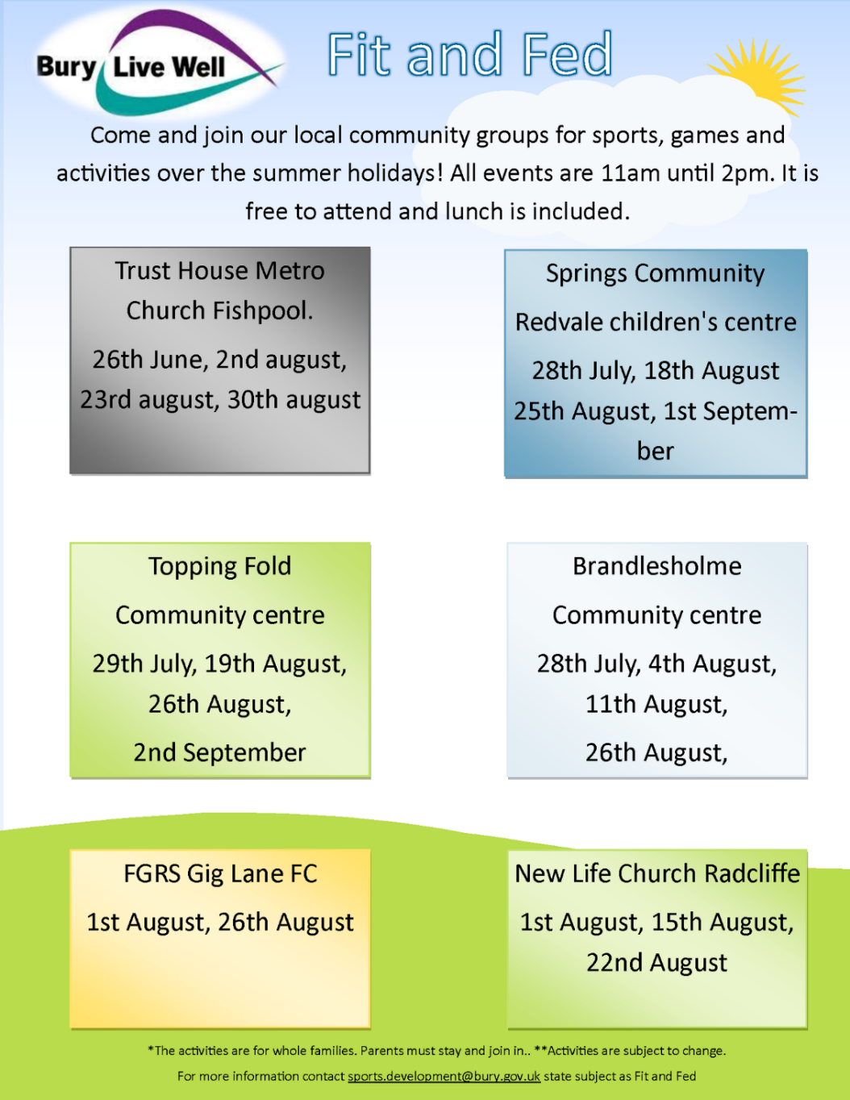

Is your [**#family**](https://www.facebook.com/hashtag/family?__eep__=6&__cft__%5b0%5d=AZXIPfM4b6BP3JOyZPMX2PUMmxNPXM7Of61ssT-QpLd0gnwbA8AG_OBfKIw890-Vd1gLWF-D54NU5VBoMcsaIC1-moQNKE6bEJA9iEd28SlitQDl3i9ueLbVYiVBjzWJQQ8XqtagbJiSD8eR20z3LcB-vPK4VAG6JiMS2-2ho35tOdu5U_b9c2eW47AEzOxYZn7fMxduvHUySzUtYNqFRwY0&__tn__=*NK*F) looking for fun [**#activities**](https://www.facebook.com/hashtag/activities?__eep__=6&__cft__%5b0%5d=AZXIPfM4b6BP3JOyZPMX2PUMmxNPXM7Of61ssT-QpLd0gnwbA8AG_OBfKIw890-Vd1gLWF-D54NU5VBoMcsaIC1-moQNKE6bEJA9iEd28SlitQDl3i9ueLbVYiVBjzWJQQ8XqtagbJiSD8eR20z3LcB-vPK4VAG6JiMS2-2ho35tOdu5U_b9c2eW47AEzOxYZn7fMxduvHUySzUtYNqFRwY0&__tn__=*NK*F) this summer? 🥅 🏓 ⚽  
  
[**Bury Live Well Service**](https://www.facebook.com/BuryLiveWell/?__cft__%5b0%5d=AZXIPfM4b6BP3JOyZPMX2PUMmxNPXM7Of61ssT-QpLd0gnwbA8AG_OBfKIw890-Vd1gLWF-D54NU5VBoMcsaIC1-moQNKE6bEJA9iEd28SlitQDl3i9ueLbVYiVBjzWJQQ8XqtagbJiSD8eR20z3LcB-vPK4VAG6JiMS2-2ho35tOdu5U_b9c2eW47AEzOxYZn7fMxduvHUySzUtYNqFRwY0&__tn__=kK*F) is organising activities over the summer holidays, offering sports and games for all the family. These are aimed for families, with children aged 5-15 years old, who may be struggling financially or otherwise.  
  
All sessions are [**#FREE**](https://www.facebook.com/hashtag/free?__eep__=6&__cft__%5b0%5d=AZXIPfM4b6BP3JOyZPMX2PUMmxNPXM7Of61ssT-QpLd0gnwbA8AG_OBfKIw890-Vd1gLWF-D54NU5VBoMcsaIC1-moQNKE6bEJA9iEd28SlitQDl3i9ueLbVYiVBjzWJQQ8XqtagbJiSD8eR20z3LcB-vPK4VAG6JiMS2-2ho35tOdu5U_b9c2eW47AEzOxYZn7fMxduvHUySzUtYNqFRwY0&__tn__=*NK*F) to attend and lunch is included. Please see flyer for locations and dates.

**Community / Voluntary Groups**

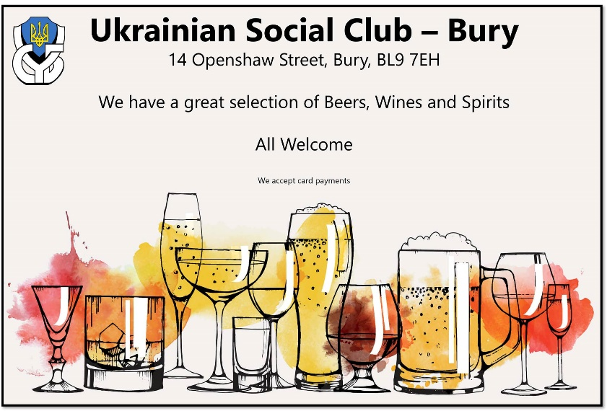

**Ukrainian Social Club, Bury**

Looking to connect with the Ukrainian community?

The centre runs a range of activities you can get involved in. They also have social activities such as their club nights.

They are running a club night tonight **16 July from 8pm.**

14 Openshaw Street, BL9 7EH Bury, UK.

For more information- 07729 600775/ 0161 764 6713

[ukrainianclubbury@outlook.com](mailto:ukrainianclubbury@outlook.com)

**The Two Tubs are proud to announce July’s Coffee and Conversation is in partnership with** [Rammy Men](https://www.facebook.com/RammyMenCIC/?__cft__%5b0%5d=AZUJrV7UDZKTTIQ2V-xhFx9t-vsGkiIlNWv8rdU1TkRBDzdH57pjUmiT2c088MEBIDWBE1007ZfkesZo0HVRKOOB6fGiAlns0RPaMvKzRZVq3XT63jyXfPUq7TKFD3YpmIv11MXRRYgw9rdXUjku0z5M9jhKoEM8aRxxY_HOXaMAb8aTBkMMF1kVJlg76rkRvKZc_WncYe8LNSTQKH18SmzC&__tn__=kK-y-R)!

Coffee and Conversation is our monthly community coffee afternoon for inspiring change and unity within our local area! ☕️🍰🧁

Rammy Men’s mission is to rebuild Bury’s community identity and sense of purpose, alongside combatting the loneliness that often accompanies mental illness.

We all know that many people struggle to open up to others and finding the right words can be difficult. Rammy Men continue to bring people together through organising a wide variety of activities that anyone can get involved in, no matter your gender!

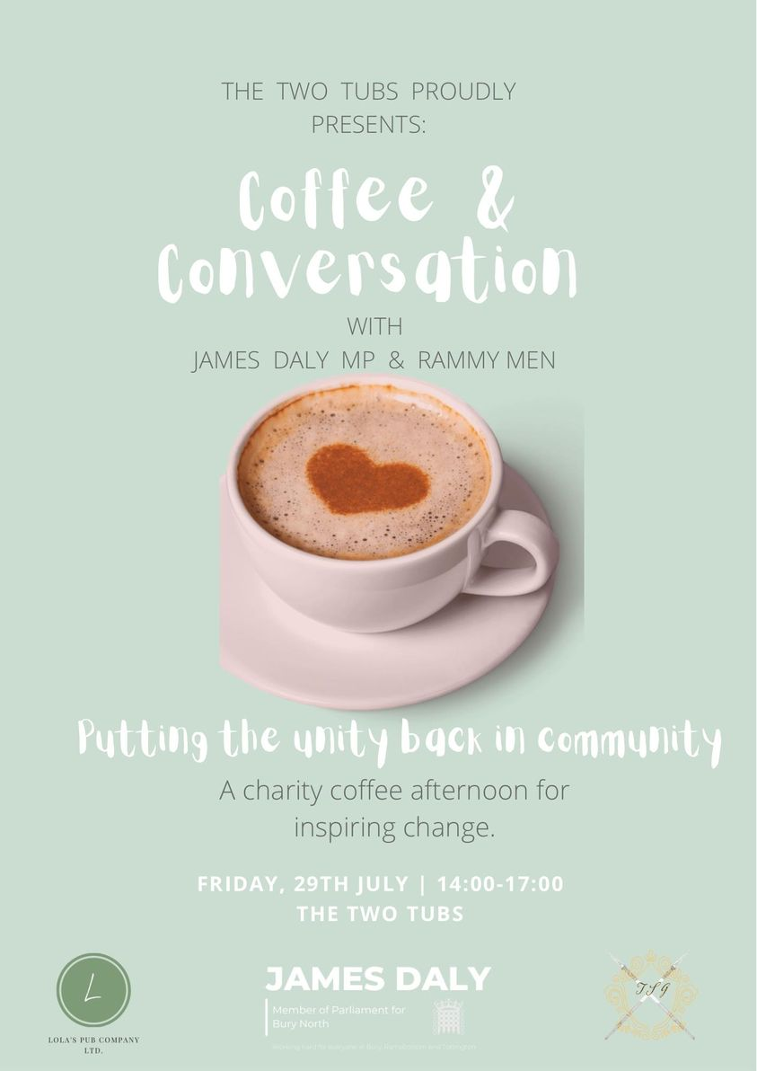Coffee and Conversation will be co-hosted by our local MP, [James Daly MP](https://www.facebook.com/groups/1670426379938596/user/100058236482350/?__cft__%5b0%5d=AZUJrV7UDZKTTIQ2V-xhFx9t-vsGkiIlNWv8rdU1TkRBDzdH57pjUmiT2c088MEBIDWBE1007ZfkesZo0HVRKOOB6fGiAlns0RPaMvKzRZVq3XT63jyXfPUq7TKFD3YpmIv11MXRRYgw9rdXUjku0z5M9jhKoEM8aRxxY_HOXaMAb8aTBkMMF1kVJlg76rkRvKZc_WncYe8LNSTQKH18SmzC&__tn__=-%5dK-y-R), and his team who will be available throughout the event to assist those in need of help; and to aid any new ideas for improving Bury for its constituents.

The Two Tubs Team will be busy baking an array of sweet treats for you all to enjoy, with the proceeds going directly to Rammy Men!👩‍🍳🧑‍🍳

This months event will be on **Friday, 29th of July from 14:00-17:00 at**

**The Two Tubs, 19 The Wylde, Bury BL9 0LA**

So for delicious baked goods, to bring forth new ideas for improving Bury, or to learn about the amazing work Rammy Men offer our community come on down!! 😃

We can’t wait to see you all! 🎉🎉

~ The Two Tubs Team

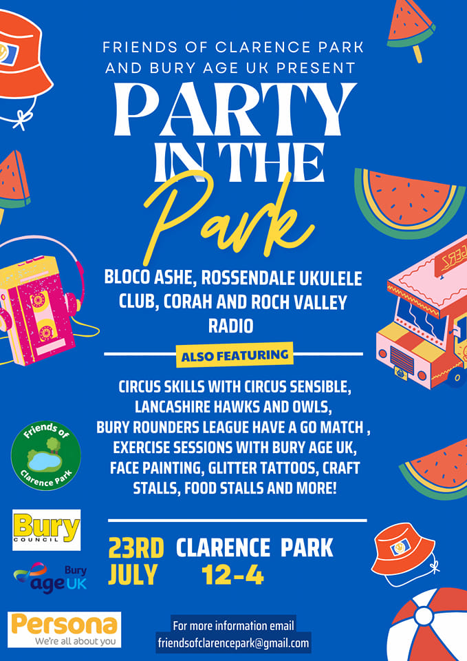

**Public Services**

**GM Big Disability Survey 2022** We know you are probably sick of being asked to fill in surveys by now, but this survey is different. We are all Disabled People’s Organisations and we use the data the survey gathers to then push to make the changes you tell us you want in the survey. The first survey already made change happen, including:

* making humanitarian aid hubs during Covid in councils more accessible
* co-producing a new Mental Health Wellbeing plan
* piloting a new concessionary fares process to include neurodiverse people
* making digital inclusion a Mayoral pledge
* making plans for transport and train stations to be more accessible, and ensuring vaccinations were accessible. We were also able to use the survey to show the Westminster government where it is failing and how it should improve policies for disabled people, if we all shout together we can’t be ignored forever! We need you to answer our survey to give us more information so we can keep the work going to make Greater Manchester a better place to live for disabled people**\***.[**Click Here To Start The Survey**](https://www.surveymonkey.co.uk/r/GMBigDisabilitySurvey22)**.** <https://gmdisabledpeoplespanel.com/>

We are also having Easy Workshop survey events for learning disability organisations and anyone who wants one! Get in touch if you want support to have a survey session!

Email: [Panel@gmcdp.com](mailto:Panel@gmcdp.com) or Text/Call: 07367 754 595



**Never Quit Quitting Campaign:** <https://makesmokinghistory.co.uk/>

GREATER MANCHESTER CELEBRATES 15 YEAR ANNIVERSARY OF SMOKEFREE LAW AS NEW CAMPAIGN LAUNCHES

It's the 15-year anniversary of the introduction of smokefree law, protecting people from second-hand smoke in restaurants, pubs, bars, shops, offices and workplaces.

Greater Manchester Health and Social Care Partnership are encouraging residents ‘Never Quit Quitting’ and seek support if you’re on your quitting journey.

If you would like to attempt to quit, visit <https://makesmokinghistory.co.uk/> for advice and support.

**Healthwatch Bury**  Please find attached the dementia survey and would appreciate if this can be distributed, it can be filled in online on our website [www.healthwatchbury.co.uk](http://www.healthwatchbury.co.uk). We can get physical copies to groups or can visit groups if they would like- contact Shirley Waller- [shirley.waller@healthwatchbury.co.uk](mailto:shirley.waller@healthwatchbury.co.uk)

**Elizabethan Suite Town Hall, Knowsley Street, Bury, BL9 0SW**

• Sunday 10 July 8.30am – 12 noon

• Sunday 17 July 8.30am – 12 noon

**Upcoming Opportunities**

Join our Bury VCFA Funding Team for our Meet the Funder briefing session to find out more about the Standing Together programme and hints and tips on strengthening your bid.

🗓️18 July 22

⌚️11am–12pm

💻Online - Zoom

Register via Eventbrite here: [https://www.eventbrite.co.uk/.../meet-the-funder-standing...](https://www.eventbrite.co.uk/e/meet-the-funder-standing-together-fund-tickets-381286005707?fbclid=IwAR0fAZ080rYZthTBV_h5kYsMCqeIxE_XNNy6htRWQaT8uabZuB5VO61svzc)



For more information about anything contained in this newsletter or to send information that you would like to be contained in the next edition, please email: [**eastcommunityhub@bury.gov.uk**](mailto:eastcommunityhub@bury.gov.uk)