NEWSLETTER

APRIL 2026

Dignifying Dementia dignifyingdementia@gmail.com
07592948878
 | IN THIS ISSUE  - Upcoming Events 2  - Regular events 2  - Jan Birthdays 4  - Music for dementia 5  SAHARA 6  - A Poem to Share 7  - Laughing Matters 8  - Word Search 9  Colouring 11  Puzzles 14

Upcoming Dignifying Dementia Events

Events are held at The Oasis Centre, Whitefield Methodist Church, Elms St, Whitefield, M45 8GQ. 14:15 – 16:00.

2nd April Easter Hat competition
16th April James Llewelyn-Burke
14th May George Quinn
18th June George Quinn
2nd July Vote for this years sing along a musical
9th July Fiddlestix
6th August George Quinn
8th October Sing along a Musical
17th December Christmas sing a long

Regular Events
DEMENTIA GROUPS IN BURY
EVERY TUESDAY
The Get Together group at The Goats Gate Inn, 83 Radcliffe New Rd, Whitefield, M45 7QZ 11:00 – 13:00. The usual mix of bingo, raffle and an entertainer.
Prestwich: The Fed Dementia Music Café. Heathlands Dr, Prestwich, M25 9SB 10:30-12:00 Please arrive at 10.30am for a 11.00am start. Please email: bernie.garner@thefed.org.uk or phone: 0161 772 4800 to Book Your Space
Music in Mind at the Jubilee Centre, Mosley Avenue, Bury, BL9 6NJ 14:30 – 16:00. please email: jubilee@ageukbury.org.uk or phone: 0161 763 9030 to book your space.
EVERY WEDNESDAY
The Get Together Group at The Woodthorpe Bury Old Rd, Prestwich, M25 0EG 10:00 – 13:00. The usual mix of bingo, raffle and an entertainer.
EVERY THURSDAY
Merrie Melodies singing group at The Oasis Centre, Whitefield Methodist Church, Elms St, Whitefield, M45 8GQ. 14:15 – 16:00.
Community Café at Nazareth House, Scholes Lane, M25 0NU14:00-16:30
FIRST TUESDAY OF THE MONTH
Tuesday Memory Club at Christ Church, Great Eaves Road, Ramsbottom, BL0 0PX 13:00 – 14:30
Sahara Memory Café for the South Asian Community at Jinnah Day Centre, Alred Street, BL9 7HE 10:30-12:30. Please ring 0161 470 6048 to reserve a place.
FIRST WEDNESDAY OF THE MONTH
Re-Kindle Memory Loss Group at Radcliffe & Stand United Reformed Church, Blackburn Street, Radcliffe M26 3WQ 13:30pm – 15:30.
LAST THURSDAY OF THE MONTH
Singing for the Brain at Fusiliers Museum, Moss Street, Bury, BL9 0DF 11:30 – 13:00
SECOND FRIDAY OF THE MONTH
D-Caff at Canon Lewis Hall, Longsight Road, BL8 4DB 13:00 – 15:00
If any of the details are wrong or you know of another group, please email the details to dignifyingdementia@gmail.com If any of the groups would like any additional detail adding please email us.


In April, we celebrate birthdays with:
2nd 1914 Sir Alec Guinness
12th 1941 Sir Bobby Moore
16th 1889 Charlie Chaplin
21st 1816 Charlotte Bronte
23rd 1564 William Shakespeare
25th 1599 Oliver Cromwell,
Special Days in the month of April
1st April Fools' Day
2nd April: World Autism Awareness Day
2nd April: International Children's Book Day
3rd-6th April Easter Weekend
9th Unicorn Day
11th April: Grand National 21st April: National Tea Day
23rd April: St. George's Day 23rd April: Shakespeare’s Birthday

MUSIC FOR DEMENTIA
Those who have joined us for a group session will know how important
we believe music to be. We follow the Charity, Play List for Life.
Playlist for Life is a music and dementia charity. The charity was founded in 2013 by writer and broadcaster Sally Magnusson after the death of her mother, Mamie, who had dementia. Our vision is simple: we want everyone with dementia to have a unique, personalised playlist and everyone who loves or cares for them to know how to use it.

The benefits of a personalised playlist
Over two decades of scientific research has shown that listening to a personalised playlist can improve the lives of those living with dementia. In fact, listening to music that is personally meaningful has many psychological benefits, meaning anyone can benefit from a playlist. Personalised playlists can: reduce anxiety, improve your mood
make difficult tasks more manageable, evoke memories that can help families and carers connect.
Playlist for Life harnesses the powerful effects of personal music to help anyone who is affected by dementia, their families and carers. Whether it’s the music from a first dance, lullabies from childhood or a theme tune from a favourite TV show, music has the ability to take us back in time and remind us of our past, giving you that flashback feeling. Sharing your songs and memories can help people living with dementia connect with family, friends and carers. Please talk to us for more info. https://www.playlistforlife.org.uk/
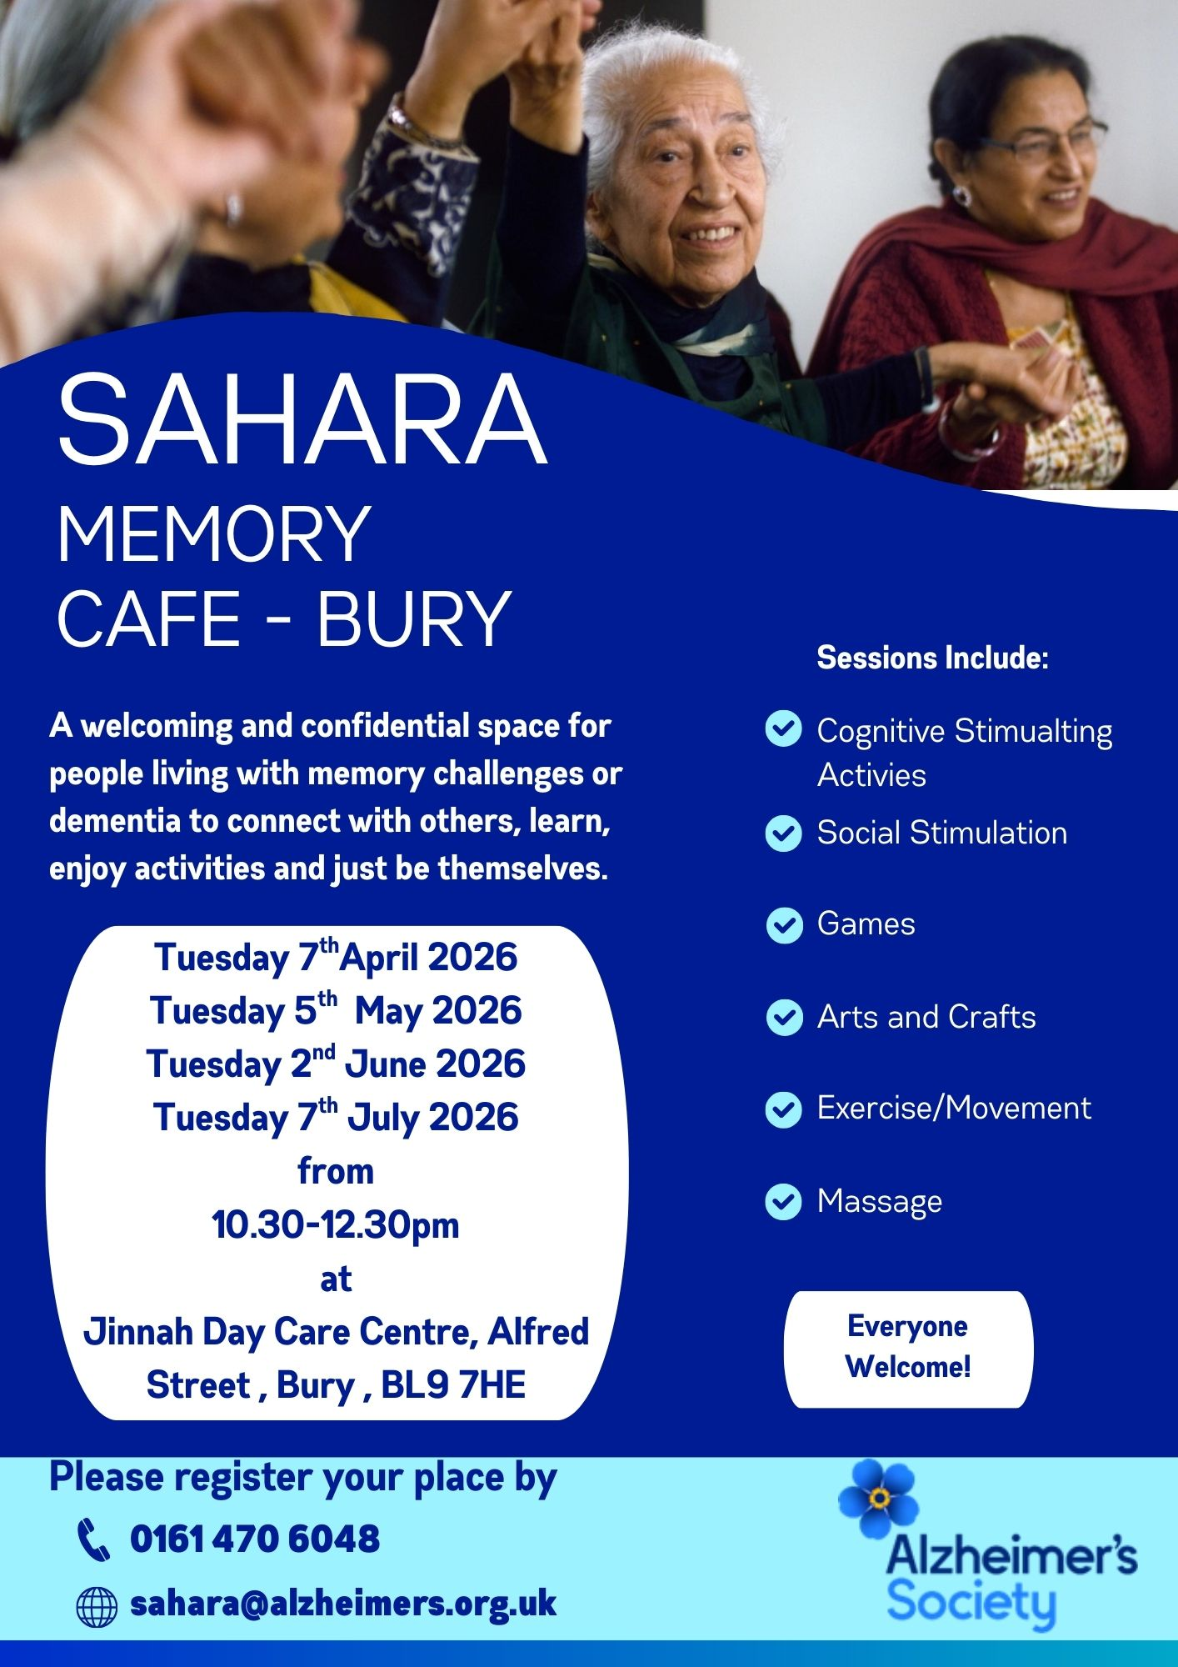

Poem to Share

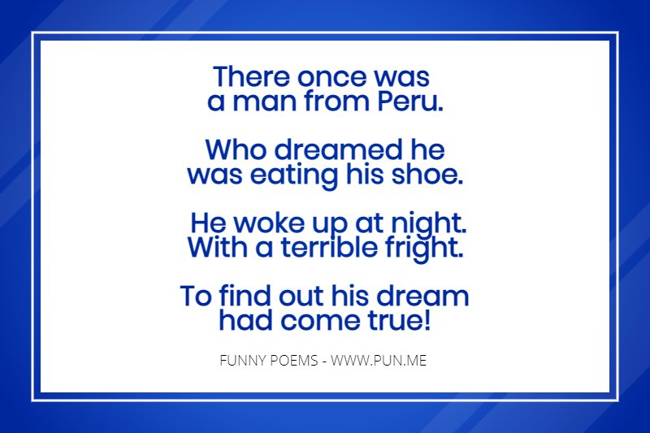

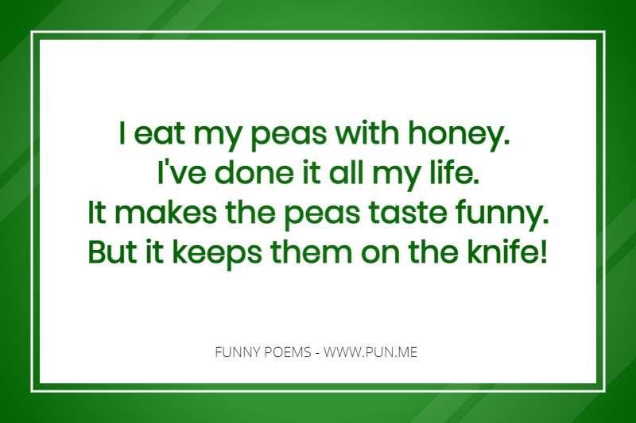


Laughing Matters

Ah, the modern days… I just saw a grandpa help a youngster who was staring into his phone, to cross the street.

Patient: “Doctor, you have to help me, I think I can see in the future.”
Doctor: “When did it start?” Patient: “Next Friday.”

Why aren’t koalas’ actual bears? They don’t meet the koalafications.

What do Alexander the Great and Winnie the Pooh have in common?
They have the same middle name.

A woman told her friend, “I feel like my body has gotten totally out of shape, so I got my doctor’s permission to join a fitness club and start exercising.” She said, “So, I decided to take an aerobics class for seniors. I bent, twisted, gyrated, jumped up and down, and perspired for an hour. But by the time I got my leotards on, the class was already over.”

I told my physical therapist I broke my arm in two places.
He told me to stop going to those places.

A retired man now volunteers to entertain patients in assisted living homes and hospitals. He visited a hospital in Brooklyn and brought along his portable keyboard. After telling jokes and singing songs at patients’ bedsides, he said farewell and, “I hope you get better.” One elderly gentleman replied, “I hope you get better, too.”
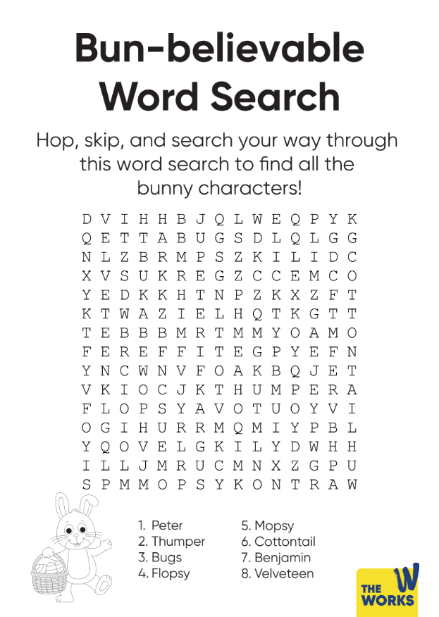

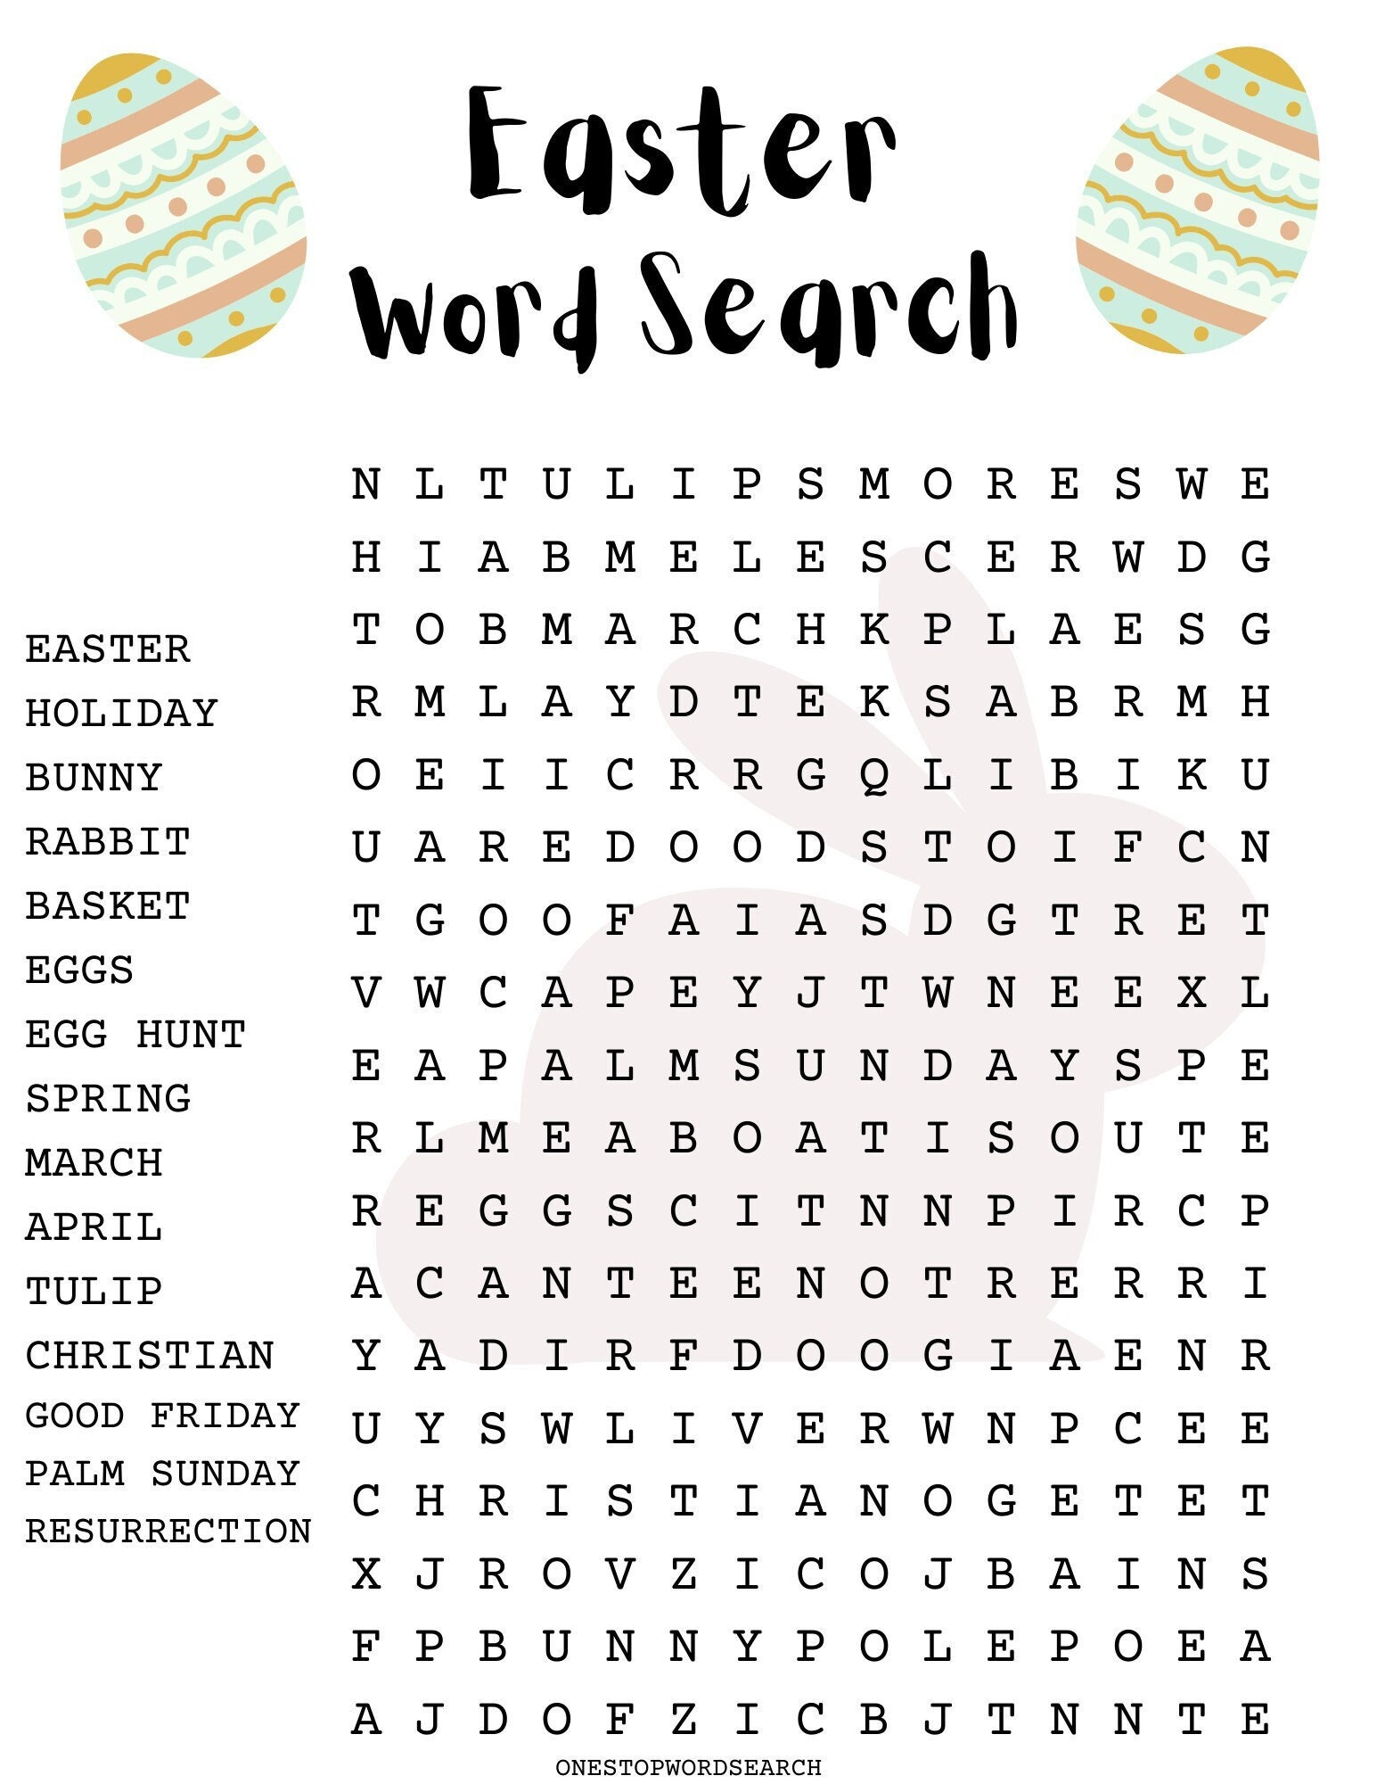

COLOURING
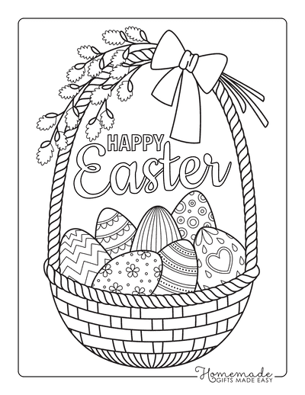

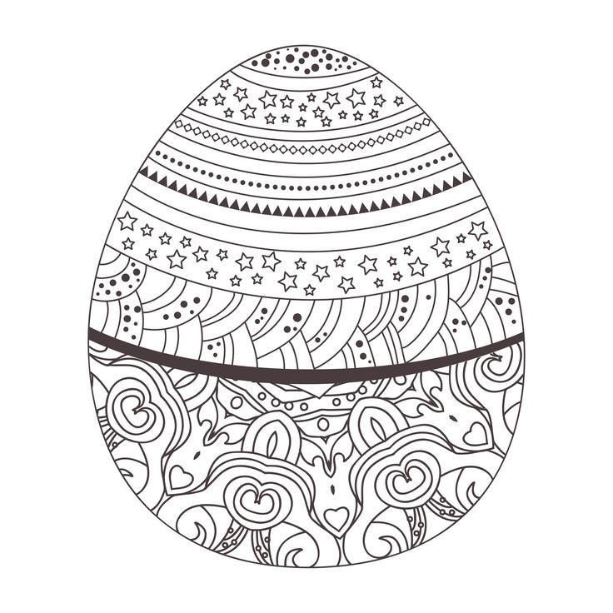

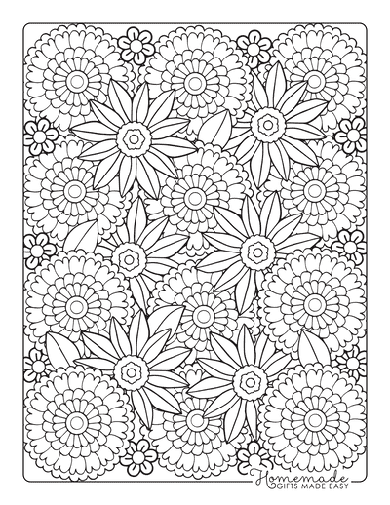

Spring/Easter Trivia Quiz
1. How many Easter eggs are bought and consumed in the UK each year?
2. When was the first Easter egg created?
3. How many eggs have gone into the world’s largest omelet?
4. The world’s tallest ever chocolate easter egg was approximately how tall? a) 8 metres b) 9 metres c) 10 metres
5. What animal delivers Easter eggs on Easter Sunday?
6. What goes on the top of a simnel cake?
7. Who is always late in Alice in Wonderland?
8. Judy Garland and Fred Astaire starred in which 1948 springtime film?
9. “It’s not Terry’s, it’s mine,” is the advertising slogan for which chocolate treat?
10. Who owns the factory in Roald Dahl’s ‘Charlie and the Chocolate Factory’?
11. What is Bambi’s rabbit friend called?
12. “How do you eat yours?” was the famous advertising slogan for what?
13. Which egg-shaped chocolate candy treat is banned in the United States?
14. True or false: the people of Mesoamerica used cocoa beans as currency?

