Share your lived patient experience with the Locality Board

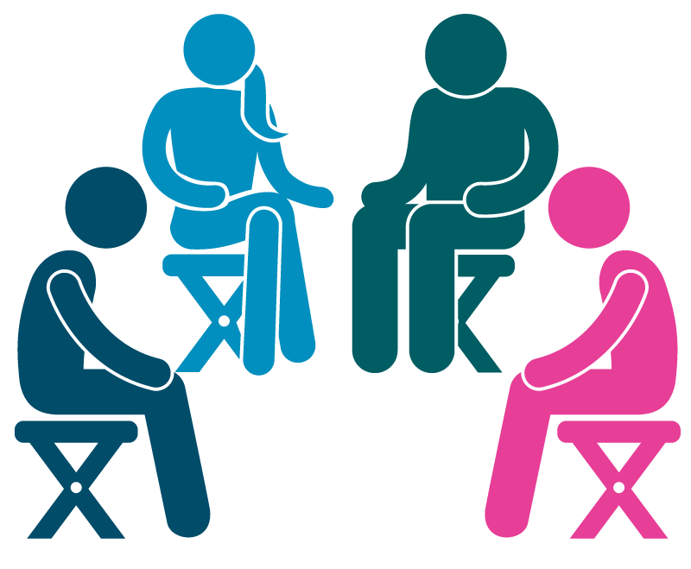
Healthwatch Bury has an exciting opportunity and would like for you to get in touch with us if you have had a recent experience with local health and/or social care services.
We are working in collaboration with the Locality Board that currently meets virtually on a monthly basis. The Locality Board includes the commissioners and service providers of local services who want to hear from patients who have had a first-hand experience and use that feedback to improve the existing services or share any good practice across the board. Your personal story could also be used to raise awareness of your condition or any communication barriers that you might face.
We are looking for patients from all ages and backgrounds and can offer support to an individual who is keen to contribute to the Locality Board but would like to run through what they may wish to highlight in terms of patient experience of the health and care system.
This is a voluntary activity, however the Locality Board are offering a small Hamper with Bury market produce as a goodwill gesture for anyone who shares their lived experience in this way.
Please get in touch by using the contact details below if you’d be interested in finding out more information about this opportunity:

Telephone: 0161 253 6300
Email: info@healthwatchbury.co.uk

