Improving discussions about resuscitation in COVID-19

We have explained some of the words that we use in our research
DNAR  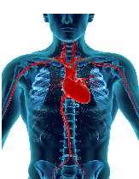  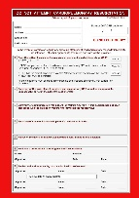 | DNAR stands for Do Not Attempt Resuscitation.  This is when doctors decide that they will not restart your heart if you become very unwell.  DNARs are also sometimes called DNRs (which means Do Not Resuscitate) or DNACPR (which means which means Do Not Attempt Cardiopulmonary Resuscitation).
Resuscitation  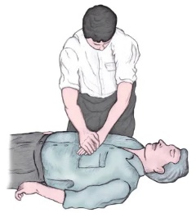 | Resuscitation is a procedure designed to restore normal breathing after cardiac arrest.  Resuscitation might include:  - the clearance of air passages to the lungs  - mouth-to-mouth method of artificial respiration  - heart massage by the exertion of pressure on the chest
What is our research about?
 | We ask relatives and carers about their experiences of resuscitation and DNAR discussions during the COVID-19 pandemic.
 | Our research will improve conversations about DNAR and resuscitation by  - informing policymakers about what works well and what needs to be improved when discussing end-of-life issues in COVID-19
Who can get involved in our research?
 | We would love to hear about your experiences  - if you are a relative or carer; and  - if you discussed resuscitation and DNAR with a medical professional on behalf of a family member or relative during the COVID-19 pandemic
What will you be asked to do?
   | Taking part involves one Zoom or telephone interview that will last approximately one hour, depending on the length of your answers.  You can decide on a date and time that is convenient for you.
Who are we?
   | We are a team of researchers from Newcastle University and the University of Manchester who have been funded by the National Institute for Health Research Policy Research Programme.
Whom to contact
 | Please contact Dr Michaela Hubmann via email: michaela.hubmann@manchester.ac.uk

