**East Bury**

**Neighbourhood Newsletter**

Updates from the East Bury Hub, community groups and partners across Bury East. To get in touch, please email: [eastcommunityhub@bury.gov.uk](mailto:eastcommunityhub@bury.gov.uk)

**Spotlight On**

**Let’s Do It Together For East Bury**

**King’s Coronation Activities The Coronation of The King and The Queen Consort will be marked with events across the country and a concert at Windsor Castle. Their Majesties want to encourage people to spend the Coronation Weekend celebrating with friends, families and their communities.**

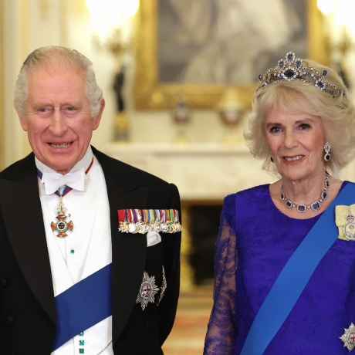

The Coronation of The King and The Queen Consort will take place at [Westminster Abbey](https://www.westminster-abbey.org/) on Saturday 6th May 2023. The Service will be conducted by [the Archbishop of Canterbury](https://www.archbishopofcanterbury.org/) and will reflect the Monarch’s role today and look towards the future, while being rooted in longstanding traditions and pageantry. **How to watch:** details of how and where to watch the service are available [on the Department for Culture, Media and Sport website.](https://www.gov.uk/government/publications/the-coronation-of-their-majesties-king-charles-iii-and-queen-camilla/how-to-watch-the-coronation-and-processions-saturday-6-may)

Schedules of Official Events including **The Coronation Concert, The Coronation Big Lunch, The Big Help Out** are listed here- <https://www.royal.uk/coronation-weekend#:~:text=The%20Coronation%20Service-,The%20Coronation%20of%20The%20King%20and%20The%20Queen%20Consort%20will,in%20longstanding%20traditions%20and%20pageantry>.

|  |  |  |  |  |
| --- | --- | --- | --- | --- |
| **Organisation** | **Date and Time** | **Location** | **Summary** | **Further details** |
| **The Fusilier Museum** | Monday 8 May, 10:00am – 4:00pm | Gallipoli Garden, Fusiliers Museum, Bury | The Bury Big Help Out King’s Coronation Party | Join us in celebrating the Coronation of King Charles III with a special programme of activities in the Gallipoli Gardens. Find out more: [The Big Help Out - Coronation Garden Party | The Fusilier Museum](https://www.fusiliermuseum.com/events/the-big-help-out-coronation-garden-party) |
| **The Rock, Bury - The King Rocks** | Monday 8 May 11:30am and 3pm. |  |  | Join us on Bank Holiday Monday, 8th May between 11:30am and 3pm as we host a truly British day of activities to celebrate this historic occasion. [Join us as we mark the King's Coronation - The Rock Bury Shopping Centre](https://therockbury.com/the-rock-whatson/join-us-as-we-mark-the-kings-coronation/) |
| **Mill Gate Shopping Centre – AR Coronation Event** | 25 April to 8 May |  |  | Join the Animal Kingdom for a hilarious Coronation event at Mill Gate Shopping Centre in Bury. From 25 April to 8 May, find out more, visit: [AR Coronation Event | Mill Gate Shopping Centre](https://millgatebury.co.uk/events/71618/ar-coronation-event) |
| **Metro Christian Centre – Coronation Big Lunch** | Sunday 7 May, 2pm to 4pm. | Metro Christian Centre, Parkhills Road, Bury. |  | Join us in celebrating the Coronation, music from Radcliffe Brass Band, farm animal, bouncy castle and BBQ. |
| **Fishpool, Goshen, Redvales and Springs Community Hub – Coronation Picnic** | Sunday 7 May from 1.30pm. |  |  | Come along, bring a picnic, and join the fun! |
| **Brandlesholme Community Centre – Coronation Coffee Morning** | Friday 5 May, 9.30am to 12 noon. | Brandlesholme Community Centre, Brandlesholme Road, Bury. |  | Join us for the King’s Coronation Coffee Morning |
| **East Lancs Paper Mill Cricket Club – Big Inflatable Fun Day** | Sunday 7 May, 1pm to 6pm. | East Lancs Paper Mill Cricket Club, Croft Lane, Radcliffe. |  | Join us for a family fun day. Wristbands: £6 per person, Family ticket: £25, non-jumpers £1.  Email [elpmccsocials@outlook.com](mailto:elpmccsocials@outlook.com) for tickets. |
| **Christ Church Ainsworth – The Big Help Out** | Monday 8 May, 11am to 3pm. | Christ Church Ainsworth, Church Street, Ainsworth. |  | Can you spare an hour or two on Bank Holiday Monday? Why not come and help us tackle some of the jobs in and around Church that just never seem to get done? |

More Coronation details are listed here- [Coronation of King Charles III celebrations - Bury Council](https://www.bury.gov.uk/local-leisure-events/coronation-king-charles)

A full list of additional events taking place across Greater Manchester is available here- <https://www.manchestereveningnews.co.uk/whats-on/whats-on-news/full-list-king-charles-iii-26822612>

* **Coronation Collection through Bury Libraries** The Coronation Collection is now available on BorrowBox through Bury Libraries. You can view the whole collection here: [Coronation Collection | Bury Libraries - BorrowBox](https://bury.borrowbox.com/product-group/17313/coronation-collection)
* **The Big Help Out-** From rolling up your sleeves to help a local group, to supporting some of the UK’s best-known national charities, the Big Help Out on Monday 8 May will give everyone an opportunity to join in. Hundreds of activities are planned for the day by local community groups, organisations and charities.If your group or organisation is based or operates within the Borough of Bury and would like support promoting your activities or volunteer opportunities on The Big Help Out (Monday 8 May 2023), please visit: [Coronation Big Help Out](https://www.esurveyspro.com/Survey.aspx?id=0b639ca4-d7e7-44de-b1a2-f7e1e6d68c60) and complete the short questionnaire which will be sent to Bury VCFA.Find out more, visit: [The Big Help Out](https://thebighelpout.org.uk/)
* **Organising your event** A range of useful templates and materials to help you with your Coronation celebrations, including homemade bunting ideas, recipe cards and kids’ activity sheets are available through [Coronation of His Majesty The King and Her Majesty The Queen Consort - Toolkit](https://coronation.gov.uk/toolkit/). Our [events and street parties](https://www.bury.gov.uk/local-leisure-events/events-guidance) page contains information you need to help organise your event, including licensing, insurance and health and safety information, as well as checklists and application forms.





