

Become a Healthwatch Bury Director
Information about the role of board member
Adam Webb | 1/31/22 | Version 1.0

What is Healthwatch?

Healthwatch Bury are an independent organisation set up to champion the views of health and social care service users.
We strive to make sure that health and social care services are meeting local needs and to ensure that the public’s voice is heard regarding how local services are run. We also work to makes sure that the public is informed on any plans to change those services, and in identifying gaps or areas where things could be better.
As a provider of trusted and accurate information to the public around health and care services, we are an important resource for the public. Additionally, our unique independent position collecting feedback and turning it into recommendations to improve the way services provide care make us a valued partner in the local system.

About the role of Director
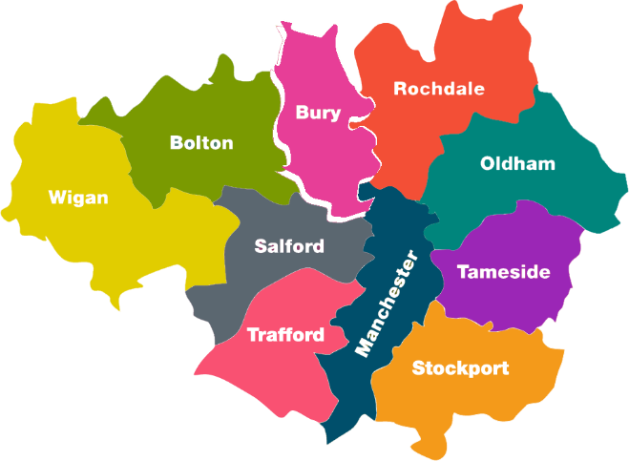
We are looking for people that live, work or use health and/or care services in Bury that are interested in becoming part of Healthwatch Bury.
We want people with local knowledge, experience and passion for promoting better health and social care for people across the borough to join our board.
You would be part of a team providing strategic direction, oversight and guidance for our dynamic staff team, as well as lending experience and skills that can help the organisation achieve its goals.

Am I the kind of person that would be great for this role?

Healthwatch Bury are committed to promoting a fair and inclusive workplace where all our people can flourish and reach their full potential. We know diverse teams allow for a more creative and productive environment and therefore encourage applications from everyone regardless of: age, gender/sex, gender identity or expression, religion or belief, disability, ethnicity or sexual orientation.
Don't worry if you have no previous experience on a board or being a director; we will provide a comprehensive induction and training where necessary. Volunteering with Healthwatch also provides a broad introduction to the wider field of work within the health sector and will be helpful to individuals interested in the area.
If you have experience in an area that we want to know more about, or possess a skillset that could help us be successful in our aims, we think we could be a great opportunity for each other.

  - A Healthwatch Bury Board Member should:
- Be able to give us the minimum time committment. Time commitment varies, however 3-10 hours a month would be a good guide, depending on how involved you wish to get in additional projects. Committee meetings vary but are roughly once every two months. There may be other events and meetings that you may wish to attend.

- Have experience or an interest in the health and social care sector in Bury. Whether your personal lived experience of services makes you an expert, or you have worked in a health or care field, knowledge of the local system would be desirable.

- Enjoy working as part of a collaborative team. The other board members, the staff team and wider teams of volunteers all work together to make Healthwatch Bury effective.

- Be diligent and take pride in their work. Committee members are expected to prepare adequately for meetings they attend. Making sure they read through reports and other documents to highlight errors, problems and issues that can then be raised in committee meetings or otherwise.

- Be able to identify areas for personal training and
self-development and attend relevant training and events as required.

  - Tasks
- Oversee governance of Healthwatch Bury, working with your fellow board members and the chair. You would be expected to attend all committee meetings where possible.

- Participate in other committees/groups where required.

- Contribute to the scrutiny of health and social care service providers in the borough of Bury to ensure that patients, service users, carers and the wider community is satisfied with the service that they receive.

- Identify, approve and oversee a range of projects through to evaluation of impact and publishing of reports.

- To oversee the development of a comprehensive community strategy to ensure We are reaching the diverse communities of Bury.

- To be involved as the outward face of Healthwatch Bury at Public Engagement events and conferences, demonstrate leadership and take an active role in public and membership engagement.

- Provide appropriate management, advice, support and challenge to the Healthwatch Bury Staff.

- Build and maintain good relationships with key stakeholders, including members of the public, patients, service users, carers, Healthwatch England, the Department of Health and Social care, the Care Quality Commission, NHS funded providers, Bury Care Organisation, the Bury Health & Wellbeing Board, and Bury Council.

Benefits of volunteering
- Being responsible for the work of Healthwatch Bury in improving the health and care landscape in the area

- Enjoying the experience of volunteering as part of a friendly team and meeting new people

- Learning new skills and gathering experience of being on a board of directors

- Using your experience with Healthwatch Bury to develop your CV

- A platform to seek out new opportunities and training for personal and professional development.


- Reasonable travel and expenses will be reimbursed in accordance with our Volunteer Policy
If you think you might be interested in becoming a member of the board of Healthwatch Bury, let us know!
By email : info@healthwatchbury.co.uk
By telephone : 0161 253 6300
By post : Healthwatch Bury, 56-58 Bolton Street, Bury, BL9 0LL

